CIF Project Part #2 Question: Can your political affiliation cause you to have a higher income?

By: Matilda Adolphsen, Quinn Murray, Logan Saito, Maxime Wilmet

Introduction (~2 Pages):

Composing the pillars of an election campaign has become a technical science, as campaigners’ market to different bases as a means to capitalize on their voting tendencies. However, election strategists, academics, and media pundits like to view people’s tendencies as consequences of psychological or external factors. Instead of evaluating how external factors, like proximity to urban communities, or psychological factors, like religious views, play a role in shaping political preferences, it could be more advantageous to evaluate how political preferences shape those factors. Identifying the extent to which political affiliation causes certain financial decisions, for example, could be beneficial in further understanding the cognitive processes of making those financial decisions. This paper evaluates the extent to which a person’s political affiliation plays a role in their income level. An approximation of the strength of this relation will be paramount in further understanding the level of determinism in career choice.
The relation between wealth and party affiliation has been investigated via many different avenues. Research has found that the political standings of a senator more closely represent the political preferences of the wealthy members of that senator’s party, on average (Maks-Solomon & Rigby, 2019). Furthermore, the paper found that there are stark differences in economic views among Republicans and social issues among Democrats across varying levels of income. Regarding how income is influenced by generalized views, Keister analyzed the role of religious affiliation on the accessibility of adult asset accumulation. She finds that the role of the family in financial processing is most responsible for asset accumulation, and she argues that the cultural role of family in religious sects is what dictates the family’s role in that processing.
Despite so much research over the relation between the two constructs, most of it assumes political affiliation is a construct that develops deep into adulthood, and that other previous factors that occur before it, like income, influence the preferences. However, the presence of social media as a source for political discovery has younger generations forming firm political beliefs at an increasingly quicker time frame (Dimitrova & Bystrom, 2013). Unlike other statistical analyses, we are assuming that a people’s political preferences have been formed, at least partially, before they have accumulated the amount of income they currently possess.

Data and Summary Statistics (1-2 Pages):

Using the dataset taken from the Cooperative Congressional Election Study (CCES), it allows users to extrapolate the relationship between American citizens and their voted-in representatives. The goal of the data set was to categorize information about the demographics of American voters, how they vote, and how Americans feel and attempt to hold their representatives accountable. Some of the variables that they asked participants about include gender, age, census region, and income. Since the study revolves around elections, the information was collected as a panel survey by interviewing 55,400 adults before (2010) and after (2014) the congressional election and with a subset of 9,500 people taking it in 2012 and 2014 for the presidential election. In this study, the variables considered are political affiliation and income, taken from each of the three years.
The data was collected by an online survey through the website YouGov. One weakness of this type of study is that it is impossible to randomize participants into a treatment and control group. Additionally, it is also hard to find a randomized sample size, especially if they do not already use the survey website. To counter this weakness, a random selection process was utilized, where a sample population was identified and from that a sample group was randomly selected following normal randomization strategies. However, this can often lead to poor retention rates and even initial participants. To solve this, the data set is taken using a model sample group, where, calculated through the website’s algorithm, it tries to select people from the website’s opt-in volunteer reserves that are closest in characteristics of the sample group. This strategy of randomization, although not perfect, does allow for one of the best versions of randomization possible in a quasi-experimental study, a strength of this dataset.

Summary Statistics for yearly household income for each year

Variable | Obs Mean Std. Dev. Min Max
-------------+---------------------------------------------------------
faminc_so~10 | 9,500 93510.53 37328.44 10000 150000
faminc_so~12 | 8,397 69281.89 31640.04 10000 160000
faminc_so~14 | 8,236 70296.26 32353.69 10000 160000

This variable is a direct scalar multiple of the coded variable in the dataset, so it does not report a precise measurement of income, only a multiple of the range of the variable. Since measurements are very large and are consistent in sample size over the multiple years, this is a good variable to analyze.
Next, we analyze party affiliation. Since the variable in the dataset contains extraneous parties and responses, we code a binary variable with the value 0 associated with a Democratic affiliation, and 1 being associated with a Republican affiliation in who a subject votes for in their election for House of Representatives. Using this variable is one of the better ways of the data set to measure political affiliation; however, since it does not directly ask participants, it is a weakness to the data set. Additionally, this does not reflect a direct measure on some political spectrum, therefore this analysis may only be applied to subjects who have switched their party vote choice over the multiple years of the survey. This variable has different sample sizes over the multiple years of the survey; however, we account for this by introducing a fixed effects model, and “combining the variables” so we can account for this in our regression analysis.

Summary Statistics for party affiliation, aggregated over all years of the survey
(0 = Democrat, 1 = Republican)
party_repub |
lican_ | Freq. Percent Cum.
------------+-----------------------------------
0 | 4,092 48.66 48.66
1 | 4,318 51.34 100.00
------------+-----------------------------------
Total | 8,410 100.00

Empirical Strategy and Results (~2 Pages):

Methods:

We choose household income as our dependent variable and regress it against who a subject voted for to represent them in the House of Representatives. Due to the nature of the dataset, we use panel data analysis, as subjects are asked the same set of questions over a span of 4 years, and 3 election cycles. The difference in the average income between Democrats and Republicans is apparent when modeled over the multiple years of the survey. Our analysis finds whether or not this difference is significant, thereby signaling a causal relationship between political party affiliation and income.
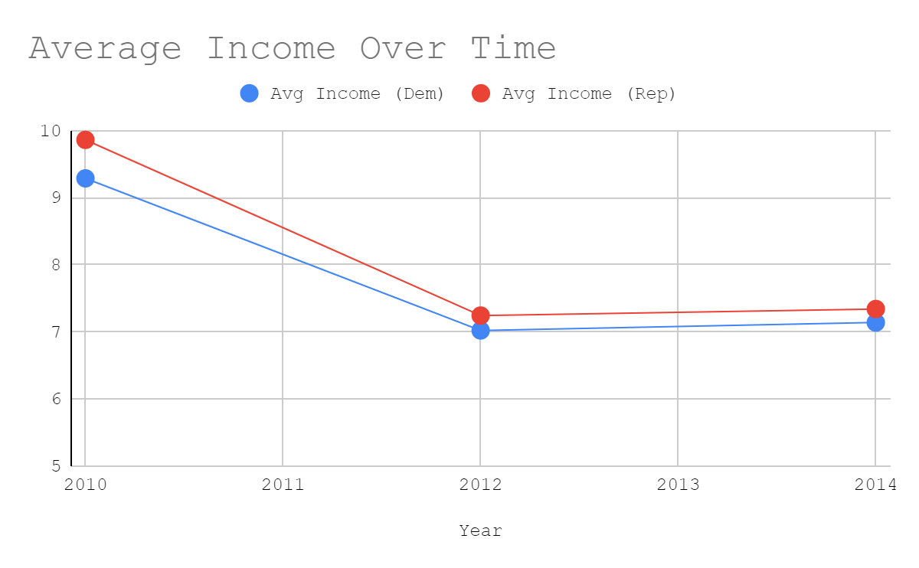

This model identifies a causal relationship, as the coefficients for these regression equations indicate if a change in political affiliation causes a change in income as well. We choose to test all of our relationships at a significance level of 0.05. In order to account for differences in subjects due to other time invariant factors, we do a fixed effects model on the subjects as well as the year the questions were asked.

$$Household Income{}_{i} = β_{0} + β_{1}(Party Affiliation){}_{i}+β_{2}(Year){}_{i} +δ_{1}(ID){}_{i} + ϵ_{i}$$

The variable δ describes the fixed effects caused by differences in subjects and years within the model. Household income is a transformed variable from ones presented in the dataset, as the dataset only specified ranges of $10,000 corresponding to a 1 unit increase in the faminc_ variables. Therefore, we multiply this by 10,000 in order to replicate a dollar amount.
We compare different models that account for varying combinations of fixed effects, as well as a simple bivariate regression between household income and party affiliation.

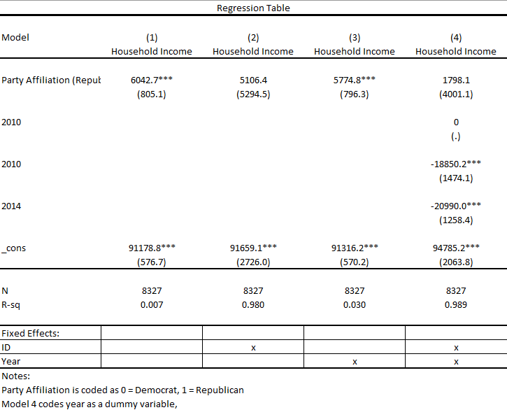

Model 4 is the model we will choose to analyze fully. The $β_{1}$estimate means that controlling for time invariant differences in subjects, someone who changes their party affiliation from Democrat to Republican experiences an $1798.10 increase in their yearly household income, on average. If they change their affiliation from 2010 to 2012, they are expected to see an $18,850.20 decrease in yearly household income, and if they change their affiliation from 2012 to 2014, they are expected to see a $20,990 decrease, on average. The estimate for $β_{0}$ concludes that the expected average yearly household income for Democrats in 2010 is expected to be $94,785.20.
The estimates for a change in house vote choice from 2010 to 2012 and 2012 to 2014 are flagged as statistically significant, with a p-value well below our significance level of 0.05. This gives us sufficient evidence to believe that a change in political party affiliation from the years stated above have a relationship with yearly household income. This makes sense in the overall context of the analysis because we are interested in changes in house vote choice, which is what the significant estimates represent. One surprising result is that when accounting for time invariant differences in subjects and years, the signs of the estimates change, likely indicating a large effect in controlling for these differences.

One potential source of confounding for the model analyzed is the employment status of subjects. This is because political events that cause the unemployment to rise and fall may cause disillusionment with one party and can be expected to cause a change in party affiliation. We estimate the same model as before, but with a dummy variable that determines whether a subject is unemployed. A frequency table for the variable of unemployment is shown below.

$$Household Income{}_{i} = β_{0} + β_{1}(Party Affiliation){}_{i}+β_{2}(Year){}_{i} + β_{3}(Employed){}_{i}+δ_{1}(ID){}_{i} + ϵ_{i}$$

Summary Statistics for employment status, aggregated over all years of the survey
(0 = Not unemployed, 1 = Unemployed)

dummy_emplo |
y | Freq. Percent Cum.
------------+-----------------------------------
0 | 27,033 94.85 94.85
1 | 1,467 5.15 100.00
------------+-----------------------------------
Total | 28,500 100.00

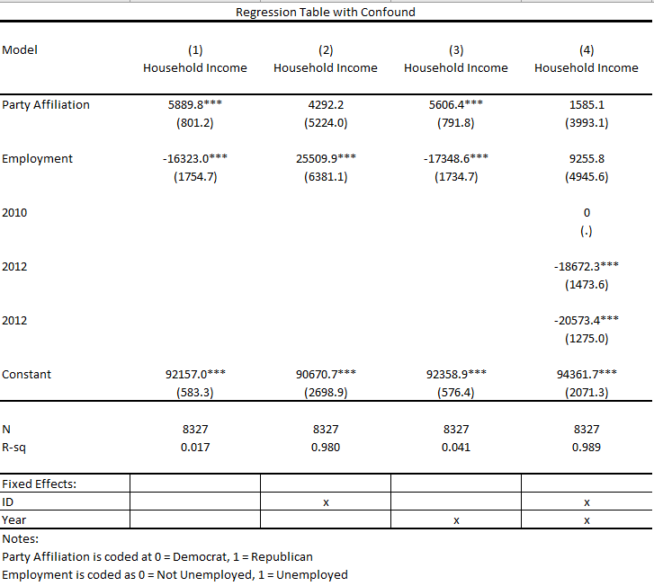

The estimate of interest belongs to the dummy variable for employment. $β_{3}$may be interpreted that controlling for time invariant differences in subjects, an unemployed person who changes their party affiliation from Democrat to Republican in 2010 is expected to have a yearly household income $9,255.80 more than an employed person in the same situation. This concludes that the exclusion of employment status in this regression model introduces a downward bias on the relationship between yearly household income and switching one’s political party affiliation.

Moreover, we again choose to analyze model 4. The $β_{1}$estimate means that controlling for time invariant differences in subjects, someone who changes their party affiliation from Democrat to Republican experiences an $1585.10 increase in their yearly household income, on average. If they change their affiliation from 2010 to 2012, they are expected to see an $18,672.30 decrease in yearly household income, and if they change their affiliation from 2012 to 2014, they are expected to see a $20,573.40 decrease, on average. The estimate for $β_{0}$ concludes that the expected average yearly household income for Democrats in 2010 is expected to be $94,361.70. These estimates seem to be very similar in magnitude to those in the regression table not accounting for unemployment. Due to the very large standard error associated with the estimate for employment, we cannot conclude that accounting for employment status introduces a significant effect on yearly household income.

